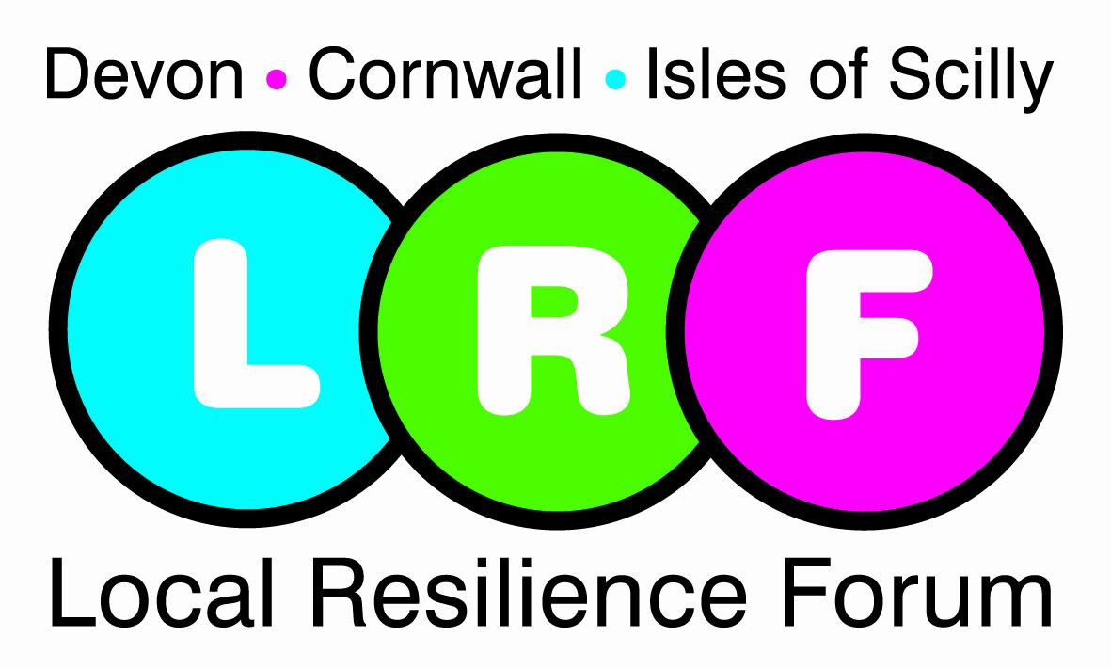



Isles of scilly

flood response plan

All items in this document are classed as open under the Freedom of Information Act unless otherwise stated. All closed items include the relevant Freedom of Information Act exemption.

Title of document: | Isles of Scilly Flood Response Plan

Author: | William Thomas/ Jenny Bagnall

Lead Agency: | Council of the Isles of Scilly

Review Date: | May 2012/ Following significant local flooding event

Revision History

Revision Date | Version No | Summary of Change | Changes made by | Authorised by | Date
08.06.10 | 1.0 | Live Version | Jenny Bagnall | William Thomas | 08.06.10
11/08/11 | 1.1 | Contacts updated | Rhona Holland | Rhona Holland | 11/08/11

Distribution

Name | Department | Organisation
Gordon Trapmore | LRF Flooding SG Chair | Environment Agency
Steve Webster | Isles of Scilly | IOS Fire Rescue Service
Dave Mawer | St. Mary’s Office | IOS Wildlife Trust
Helen Hutson | Resilience Operations | Maritime Coastguard Agency
Bill Martin | Emergency Planning | South West Ambulance Service Trust
Dean Whillis | Operations Manager | Tresco Estate
Rhona Holland | Emergency Planning | Council of the Isles of Scilly
Phillip Hygate | Chief Executive | Council of the Isles of Scilly
Craig Dryden | Planning Department | Council of the Isles of Scilly
Neville Gardner | Technical Services | Council of the Isles of Scilly
Penny Penn-Howard | Community Services | Council of the Isles of Scilly
Chris Gregory | Isles of Scilly | Duchy of Cornwall
Simon Wilkins | Contingency Planning | Devon & Cornwall Police
Caroline Wildish | Business Command Unit | Devon & Cornwall Police
Colin Taylor | St. Mary’s Station | Devon & Cornwall Police

This Plan is owned by the Devon, Cornwall and Isles of Scilly LRF, maintained, and updated by the LRF Flooding Subgroup. All users are asked to advise the Secretariat of any changes in circumstances that may materially affect the plan in any way.

Details of changes should be sent to:

Devon, Cornwall and Isles of Scilly Local Resilience Forum Secretariat

Email lrf@devonandcornwall.pnn.police.uk

Contents

Introduction 3
Aim 3
References to Other Plans 4
The Definition of “Emergency” 5
Procedure for Implementation of Emergency Plans 5
Types of Flooding 5
Flood Risk 6
Notification 6
Dissemination of Warnings 6
Flood Response Measures (Pre-event) 7
Authorities involved in an incident of flooding 8
Action Lists in the event of a flooding incident on the Isles of Scilly 8
Evacuation and shelter 10
Recovery 10
Annex A 1
Facilities/buildings for vulnerable groups 1

Introduction

The Isles of Scilly consists of more than 200 low-lying granite islands and rocks, five of which are inhabited. It is located on the edge of the Atlantic, some 28 miles South West of Land’s End. The Islands’ land area covers approx 18 square km. St Mary's is the largest island and has a highest point of 51 metres.
Apart from freehold land in the built up areas of St Mary’s, the Islands are entirely owned by the Duchy of Cornwall. Untenanted land and the uninhabited islands are let by the Duchy to the Isles of Scilly Wildlife Trust; the whole of Tresco separately to Tresco Estate.
The Council is the only remaining public water and sewerage authority left in England and Wales. It runs essential systems on St Mary’s and Bryher.
There is documented evidence that shows that the Isles of Scilly has suffered storm flooding at varying intervals during the past few centuries. Recent events of flooding on the Islands include the storm of 16th and 17th December 1989 that damaged defences at Porthcressa and overtopped defences at Old Town and Porthloo on St. Mary’s and more recently the flooding of 2005. Since this time, significant work has been undertaken to improve sea defences and increase drainage capacity at the most vulnerable flood areas on the Islands.

Aim

This document outlines the roles and responsibilities of the Council of the Isles of Scilly within the co-ordinated response of a number of agencies to an incident of flooding. The aim of any response is to mitigate the effects of an incident on people, infrastructure and the environment and aid recovery.

It is the responsibility of owners and occupiers of properties to protect their property in the event of flooding.

In summary this plan details:

- Flood risk
- How flood and severe weather warnings are disseminated
- Measures undertaken when the risk of flooding is perceived
- The roles and responsibilities of agencies that might be involved in the response to an incident of flooding on the Isles of Scilly
- Evacuation and shelter
- Recovery

References to Other Plans

This Flood Response Plan addresses only those issues which are not already covered in other plans maintained by the Council and the Devon, Cornwall and Isles of Scilly Local Resilience Forum (LRF). These other plans include the following.

Council of the Isles of Scilly Plans
Emergency Procedures Guide (EPG) | A guide primarily for Council staff. The EPG details the arrangements for call-out of staff and the management structure and establishment of an Emergency Operations Centre. The Council response to a major flooding incident will be in accordance with these procedures.
Rest Centre Plan | This plan sets out the procedures for shelter and care of evacuees. There may be a demand for temporary accommodation for those made homeless through major flooding and the plan will be implemented as required.
Communications Plan | This plan forms part 2 of the EPG and contains both Council and inter-agency communication information.
Community Risk Register (CRR) | Document identifying the significant risks facing the community and enabling categorisation of those risks.
Shoreline Management Plan (SMP2) (draft) | The SMP2 provides an assessment of risks associated with coastal processes and details how the Isles of Scilly is adapting to the challenge of climate change.
Devon, Cornwall and Isles of Scilly LRF Plans
Devon, Cornwall and Isles of Scilly LRF Combined Agency Emergency Response Protocol (CAERP) | Overarching protocol agreed by the Devon and Cornwall and Isles of Scilly LRF by which all emergencies (as defined by the Civil Contingencies Act 2004) are managed in the LRF area.
Devon, Cornwall and Isles of Scilly LRF Multi Agency Flood Plan (MAFP) | A structure for integrated emergency management required for a flood incident which has occurred in the LRF area. This plan will only be activated if a major incident is declared. The Isles of Scilly Flood Response Plan forms an Appendix to the MAFP.

The Definition of “Emergency”

“Emergency” is defined in Part 1 of the Civil Contingencies Act as: An event or situation which threatens serious damage to human welfare in a place in the UK, the environment of a place in the UK, or war or terrorism which threatens serious damage to the security of the UK.

The definition of “emergency” is concerned with consequences, rather than with cause or source. Therefore, an emergency inside or outside the UK is covered by the definition, provided it has consequences inside the UK.

Procedure for Implementation of Emergency Plans

The Chief Executive of the Council (or in his absence the Deputy Chief Executive), will authorise the implementation of emergency plans when he considers at least one of the following tests are met:

- where the emergency would be likely to seriously obstruct the councils ability to perform its functions.

- where the Council would consider it necessary or desirable to act to prevent, reduce, control or mitigate the emergency’s effects, or otherwise take action; and

- would be unable to act without changing the deployment of its resources or acquiring additional resources.

If a situation directly affects the Isles of Scilly, then the Chief Executive (or his deputy) has the authority to declare an emergency and implement appropriate emergency plans, advising the Chairman and Vice Chairman of the Council as soon as is practicable.

It must be borne in mind that other Category 1 Responders may declare an emergency before the Council. In this event, the Chief Executive, in consultation with the Resilience Lead, will evaluate the risks to the Isles of Scilly to determine the appropriateness of implementing appropriate emergency plans.

Types of Flooding

Coastal (Tidal) Flooding – Coastal flooding occurs when the sea level rises above the level of coastal land. This can be caused by tidal movements, ground swell, strong winds or other extreme weather conditions and can be exacerbated by low barometric pressure and/or heavy rainfall.

River (Fluvial) Flooding – not applicable to the Isles of Scilly

Surface Water (Pluvial) flooding – Surface water flooding occurs when natural and man-made drainage systems have insufficient capacity to deal with the volume of rainfall. It generally happens quickly and can be hard to predict. The critical factors for surface water flooding are the volume of rainfall, where it falls and its intensity.

Groundwater flooding - Groundwater flooding occurs when the level of water underground (the ‘water table’) rises and water emerges above the natural surface. It generally happens in low-lying areas.

Flood Risk

The threat of flooding to the Islands is predominately from coastal flooding. There is a chance that coastal flooding can occur when the tides are particularly high and if they coincide with bad weather conditions such as high winds and wave surges. Properties at or below sea level are most at risk. On St. Mary’s this applies to parts of Hugh Town and in respect of one storm direction some properties located near to the sea wall on Old Town Road and Trench Lane. The Porthcressa sea defences have greatly reduced the threat to Hugh Town and additional storm drains have been created in Old Town.
The Council as a Local Planning Authority will take account of flooding risks in all matters relating to development control, including development plans and individual planning applications, in accordance with Planning Policy Statement 25.
The Council of the Isles of Scilly Shoreline Management Plan (SMP2) (draft) provides an assessment of risks associated with coastal processes and provides a basis for deciding policy. The council has a recent history of improving and replacing sea defences in vulnerable areas across the islands including works on St. Agnes, Bryher, Tresco and St. Mary’s.

As a Category One Responder, the Council has a duty under the Civil Contingencies Act (2004) to undertake risk assessments to ensure that plans are in place to respond to any incident that may occur. In the Isles of Scilly Community Risk Register (CRR), the risk of major tidal flooding is assessed as ‘medium’ and the risk of flash flooding arising from heavy localised rainfall is assessed as ‘low’.

These are the only risks identified in the Isles of Scilly CRR relating to flooding.

Notification

The Flood Forecasting Centre (FCC) is a partnership between the Environment Agency and the Met Office combining meteorology and hydrology expertise to forecast tidal and coastal flooding as well as extreme rainfall which may lead to surface water flooding.

The FCC provides the following to the council via e-mail, text alert and/or fax:

- Extreme Rainfall Alerts
- National Flood Guidance Statements

The Council also receives Severe Weather Warnings from the Met Office via the National Severe Weather Warning Service (NSWWS). These warnings cover a wide area and are therefore not always specific to the Isles of Scilly.

Dissemination of Warnings
Provision of flood warning systems is the responsibility of the Environment Agency. However, the Council of the Isles of Scilly, as a Category 1 responder under the Civil Contingencies Act 2004 has a duty to warn, inform and advise the public in the event of an emergency.
To ensure that the public are kept advised well in advance of potential flooding incidents weather is monitored, particularly when there are significant Spring tides. When weather/flood warnings are received, or if felt necessary, precautionary warnings of potential flooding are advertised as follows:
- Council website
- Community Message Board
- Tourist Information Office – front window
- Town Hall
- Radio Scilly
- Radio Cornwall
- Posters in various locations
- Where deemed appropriate – door knocking in specific vulnerable areas or in the case of off islands telephone calls
- Direct to IOS Fire and Rescue Service
General flooding advice is provided on the Council website and Z-Cards have been produced and distributed to all households giving information about how to be prepared in the event of an emergency including flood incidents.

Flood Response Measures (Pre-event)

In addition to warning and informing the public, the Council of the Isles of Scilly will undertake the following as deemed necessary based on the information available to them:

- Additional checks of storm drains (particularly those in known vulnerable flood risk areas).
- Deploy storm boards on the Atlantic Slipway, Thoroughfare and Porthmellon beach (St. Mary’s) as required.
- 1 ton sandbags (kept loaded in storage) are ready to be deployed in Old Town (St. Mary’s). A chicane is formed using these bags across Old Town Road (from the corner of Trench Lane and ‘Dolphins’) leaving the road passable to traffic. Additional bags are placed on site should the need arise to close off the chicane forming a wall and close the road.
- If required IOS FRS will standby to pump out any water that breaches this barrier.
- Sandbag Hugh Town (St. Mary’s) pumping station.

Arrangements are in place with local haulage firms for the transportation of sandbags.

Authorities involved in an incident of flooding

The following organisations can be involved in specific action during a flooding event on the Isles of Scilly. Property owners are listed as it is their responsibility to protect their own property from flooding.

- Environment Agency
- Council of the Isles of Scilly
- Devon and Cornwall Constabulary
- Isles of Scilly Fire and Rescue Service
- South Western Ambulance Services Trust
- Maritime and Coastguard Agency
- Utility Companies
- Property Owners

Action Lists in the event of a flooding incident on the Isles of Scilly

Environment Agency
The principal actions of the EA are:

- Issue flood warnings
- Monitor the situation and advise other organisations

Council of the Isles of Scilly
The principal actions of the Council in response to a flooding incident include:
- Facilitate a Multi Agency Joint Operations Centre if required as outlined in the Council’s Emergency Procedures Guide (EPG)
- Maintain safe conditions on the roads
- Put flood warning signs on the highway
- Organise road closures and traffic diversions
- Clear blockages of highway drainage systems
- Flood warning dissemination
- Environmental health issues – pollution
- Blocked road channels & gully gratings - street cleaning
- Provide temporary accommodation, set up and run rest centres
- Clearing blockages in mains sewers
- Repairing burst mains and sewage systems
- Action to protect property from flooding or discharges from the mains sewerage systems
- Provision of fresh water supplies
- Arranging special refuse collections of flood waste
- Where a major incident is declared the Council will carry out their role as outlined in the Devon, Cornwall and Isles of Scilly LRF CAERP.

Devon and Cornwall Constabulary
The principal actions of the Police are:

- Protection of life and security of property (where practicable) in affected areas
- Co-ordination of the initial control of response activity in affected areas;
- Traffic control (if required);
- Notification of other emergency services;
- Controlling evacuation where required;
- Casualty bureau (if required);
- Where a major incident is declared the police will take the full co-ordination role as outlined in the Devon, Cornwall and Isles of Scilly LRF CAERP.

Isles of Scilly Fire & Rescue Service
The principal actions of the FRS are:

- Rescue of trapped persons
- Recovery of deceased in consultation and co-operation with the Police;
- Dealing with any fires or chemical hazards;
- Assistance with pumping out of properties;
- Where a major incident is declared the fire service will carry out their role as outlined in the Devon, Cornwall and Isles of Scilly LRF CAERP.

South Western Ambulance Services Trust
The principal actions of the Ambulance service are:

- To remove casualties to designated hospitals;
- Set up casualty clearing stations as required;
- Arrange any medical assistance as required;
- Act as the ‘gateway’ to other health services;
- Where a major incident is declared the Ambulance service will carry out their role as outlined in the Devon, Cornwall and Isles of Scilly LRF CAERP.

Maritime and Coastguard Agency (MCA)
Subject to maritime search and rescue operations permitting, the MCA will:

- Respond to emergency flooding incidents when requested by local authority or police but response will be subject to availability of resources and primary search and rescue role activities elsewhere;
- Rescue where both MCA training and equipment allow;
- Assist the local population where a need is identified and MCA involvement is justified but again subject to availability of resources and primary search and rescue activities elsewhere.

Utility Companies
The principal actions of the utility companies are:

- Attend to emergencies relating to their service at properties putting life at risk as a result of flooding;
- Attend to flooding emergencies at their own service installations.

Property Owners
The principal actions of owners of property at risk of flooding or which is flooded are:

- Prepare a personal emergency plan;
- Move to a safe area if life is at risk;
- Prevent water from entering property if possible;
- Switch off electricity and gas at supply;
- Move valuable possessions above floor areas liable to be flooded.

This is not an exhaustive list as there are other agencies whose services would be activated as required including voluntary agencies both medical and community based.

Maps detailing facilities/buildings for vulnerable groups such as the young and elderly are at Annex A.

Maps detailing utilities critical infrastructure are at Annex B (not for publication - this information will be available to the Council’s Crisis Management Team and multi agency partners in the event of a major incident being declared).

Evacuation and shelter

National guidelines suggest that the public should be encouraged to shelter unless there is a clear and obvious danger to life. A decision to evacuate would be taken by the Police Incident Commander with advice from other responding agencies. Any evacuation would be undertaken in accordance with the Devon, Cornwall and Isles of Scilly LRF CAERP.

If the decision is made to evacuate properties as a result of flooding, the Council will, if required, open a designated Rest Centre in accordance with the Council’s Rest Centre Plan.

Recovery

If required a Recovery Team may be formed to manage recovery and restoration to normality following an incident of flooding. The Chief Executive and members of the Council’s Crisis Management Team will agree the need for and composition of the Recovery Team.

Issues may include:

- Co-ordination of support to the wider community
- Temporary accommodation
- Facilitation of a Humanitarian Advice Centre (advice and information such as Insurance, legal advice, co-ordination with utility providers)
- Waste management
- Co-ordination of repairs to Council owned/leased property
- Compilation of appropriate claims, e.g. Bellwin Scheme
- Management of relief funds

Annex A

Facilities/buildings for vulnerable groups

St. Martins
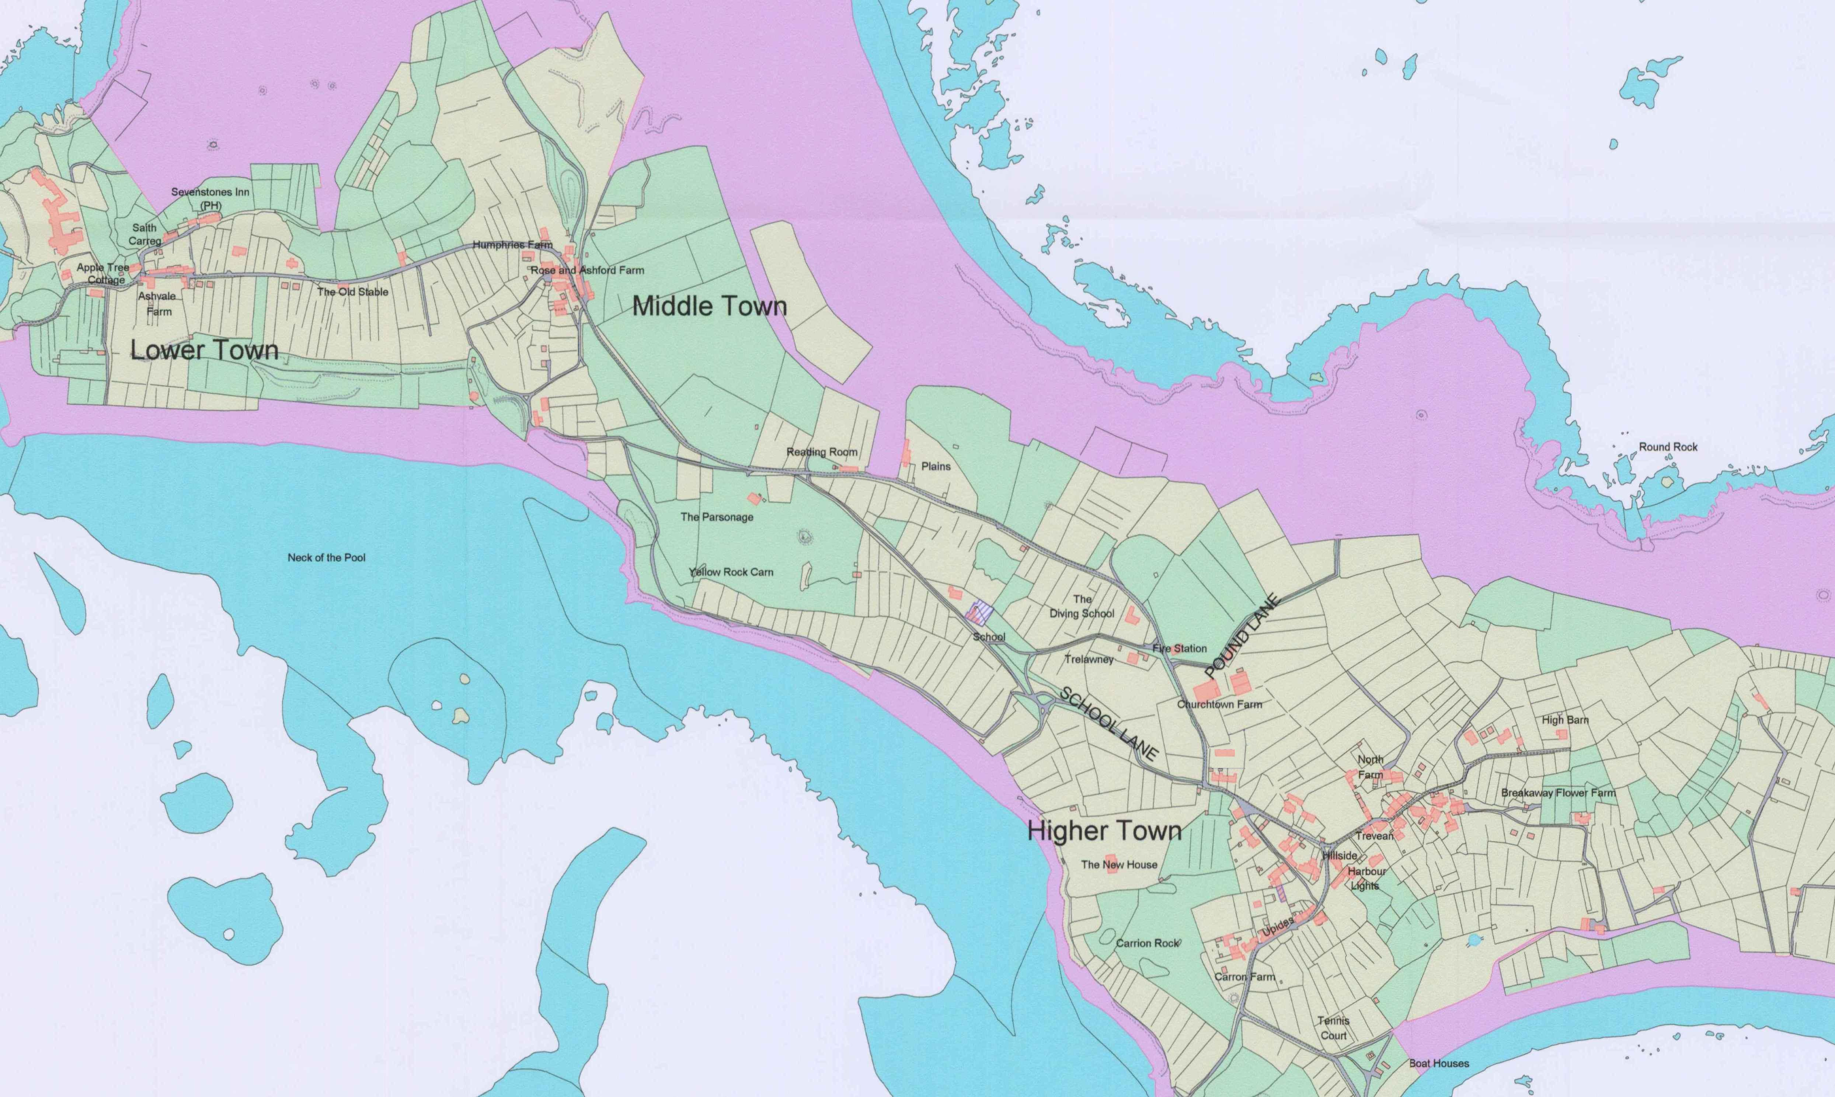
Five Islands School – St. Martin’s Base

St. Agnes

Five Islands School – St. Agnes Base

St. Mary’s

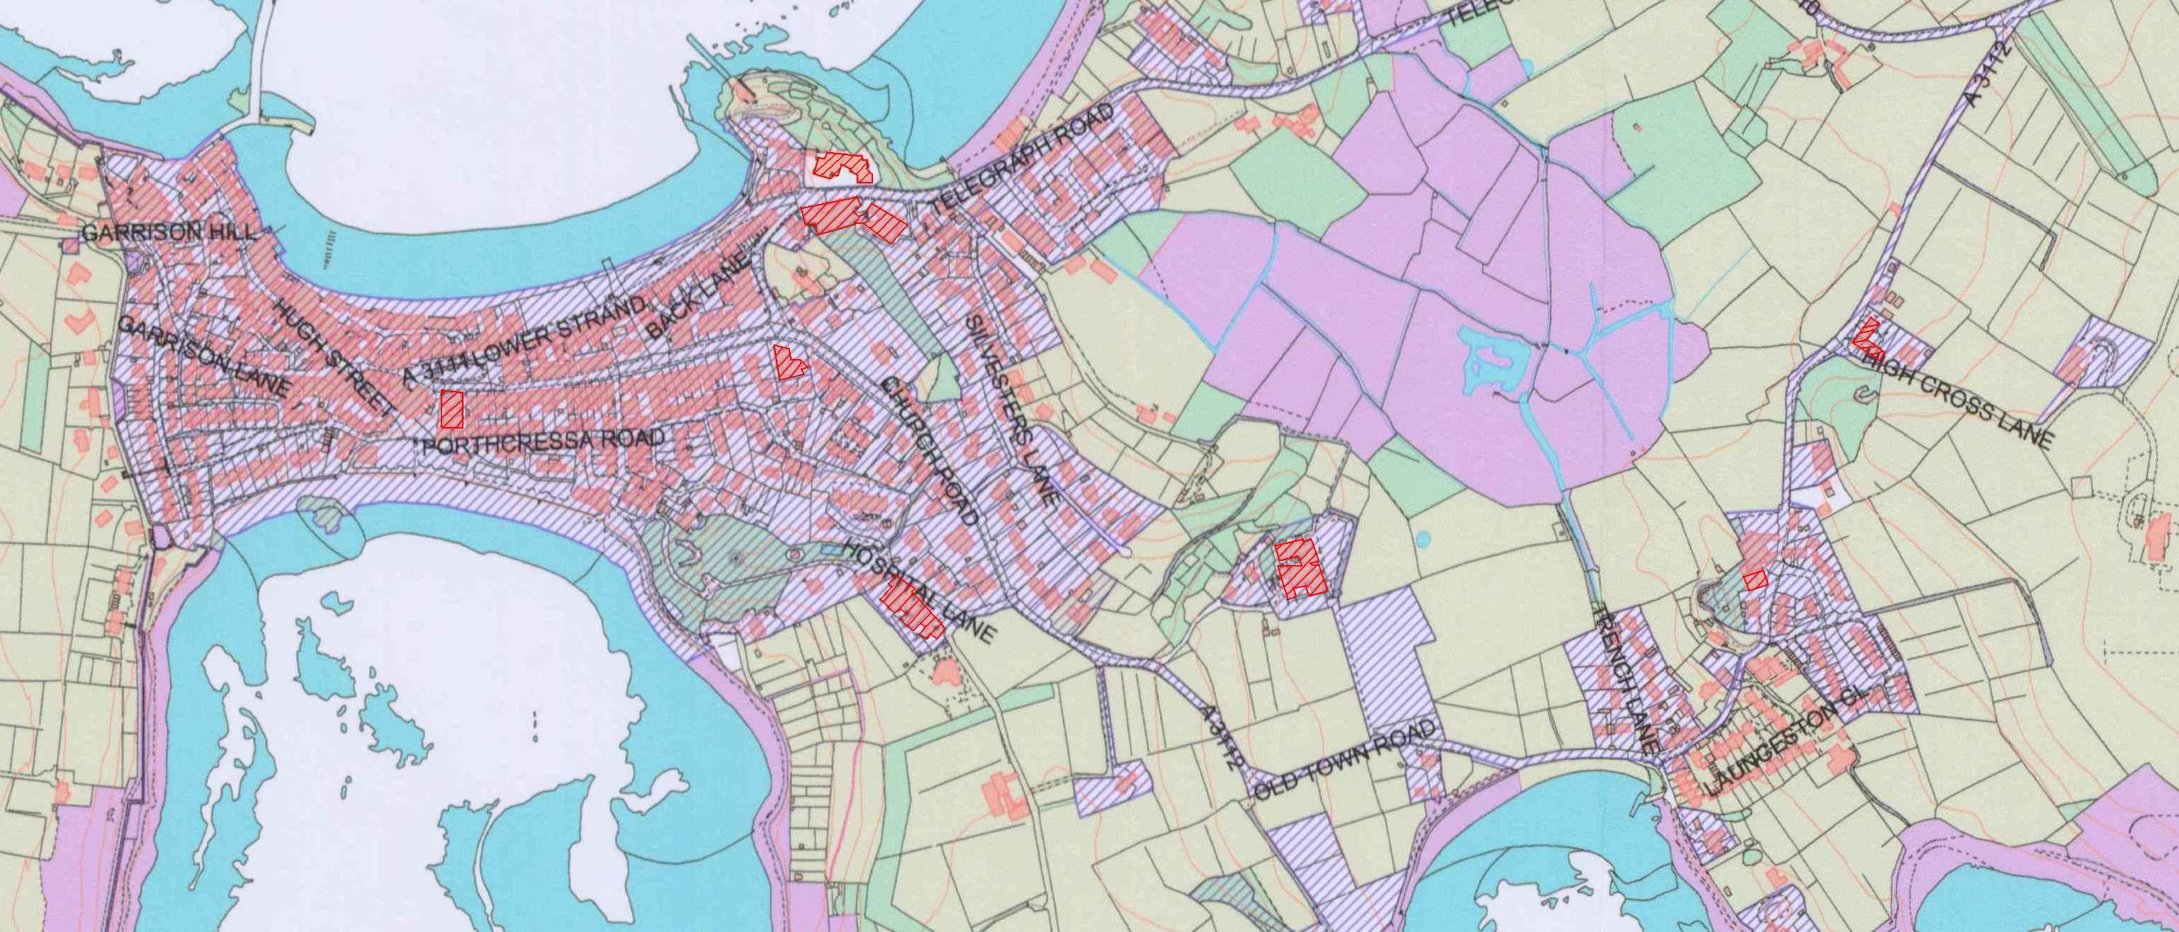
Park House Care Home
St. Mary’s Hospital
Crafty Kids Nursery
Hanover Court
Sheltered Housing
Carn Thomas
Children’s Centre
Five Islands School
Carn Gwavel and Secondary bases
Mundesley Hostel

Tresco
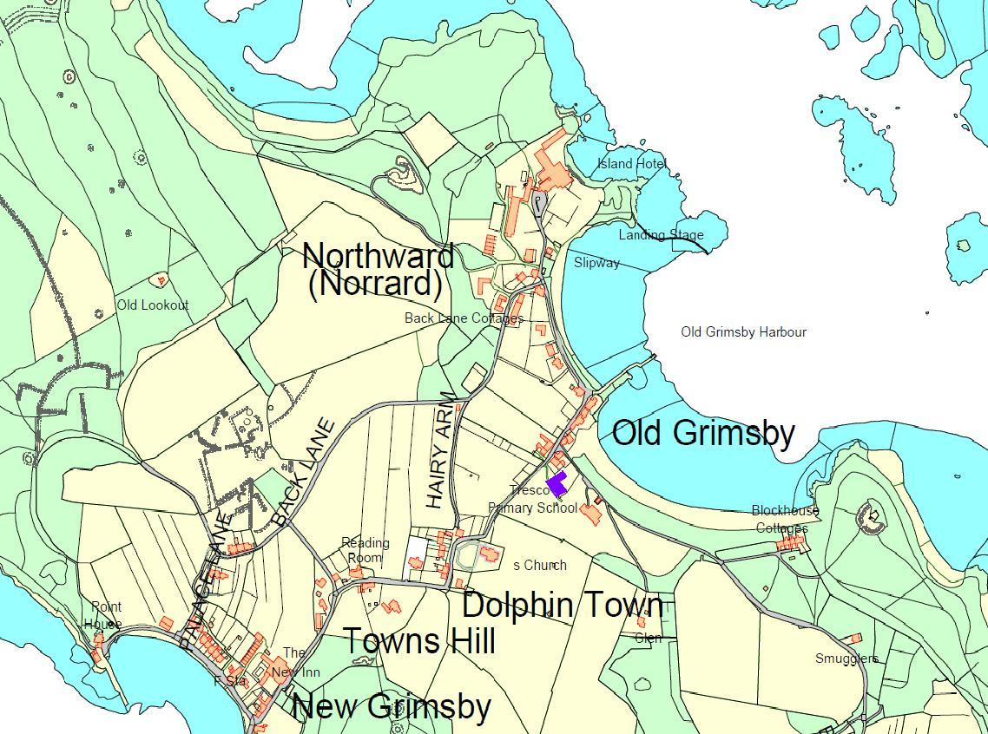
Five Islands School
- Tresco Base

